## audio_maps table

## Fields

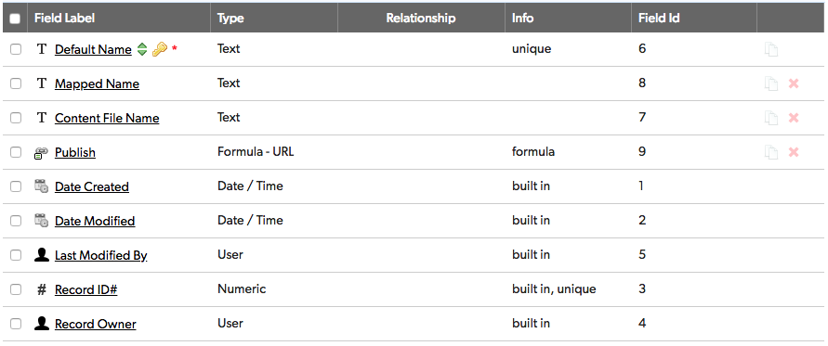

## Field settings

Note: Built-in fields use the default settings

Default Name 2

Mapped Name 3

Content File Name 4

Publish 5

# Default Name

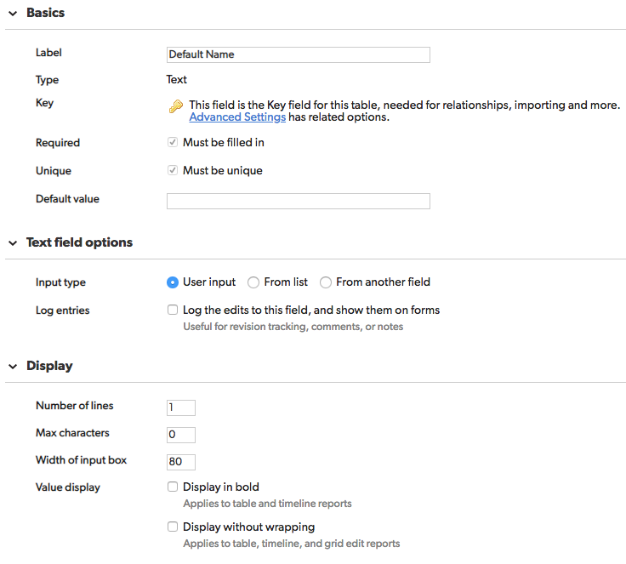

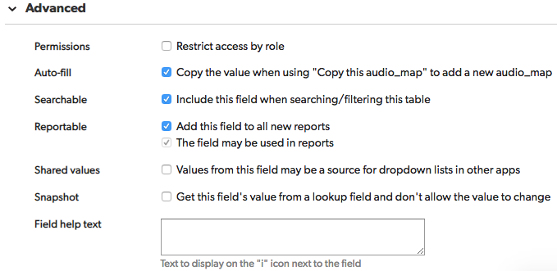

# Mapped Name

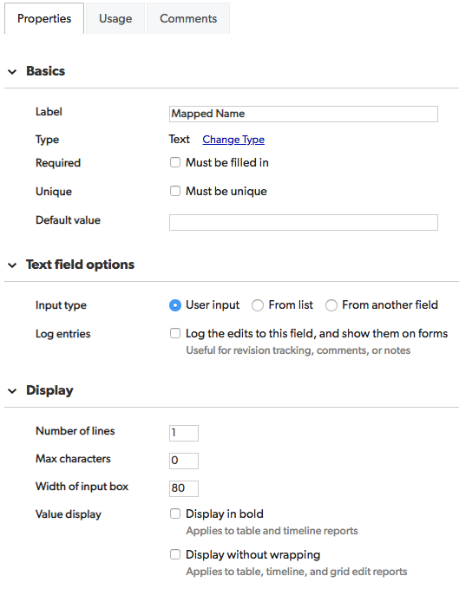

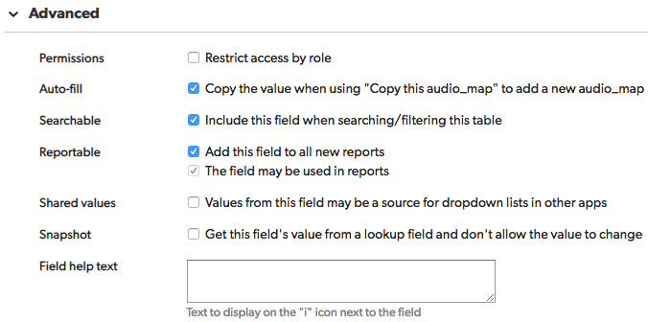

# Content File Name

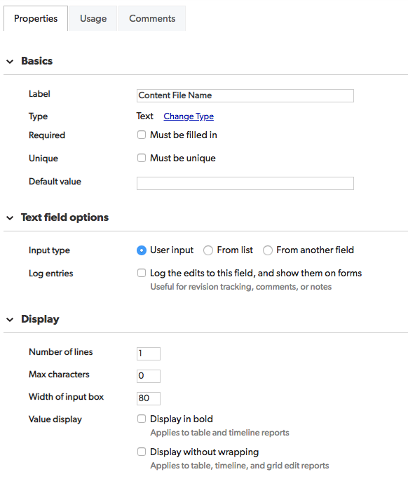

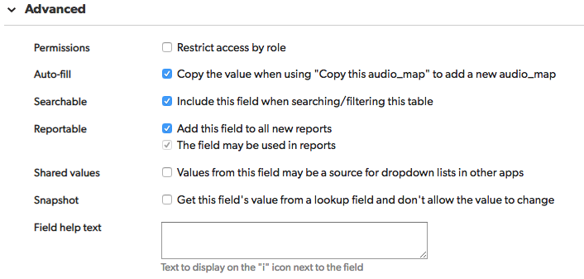

Publish

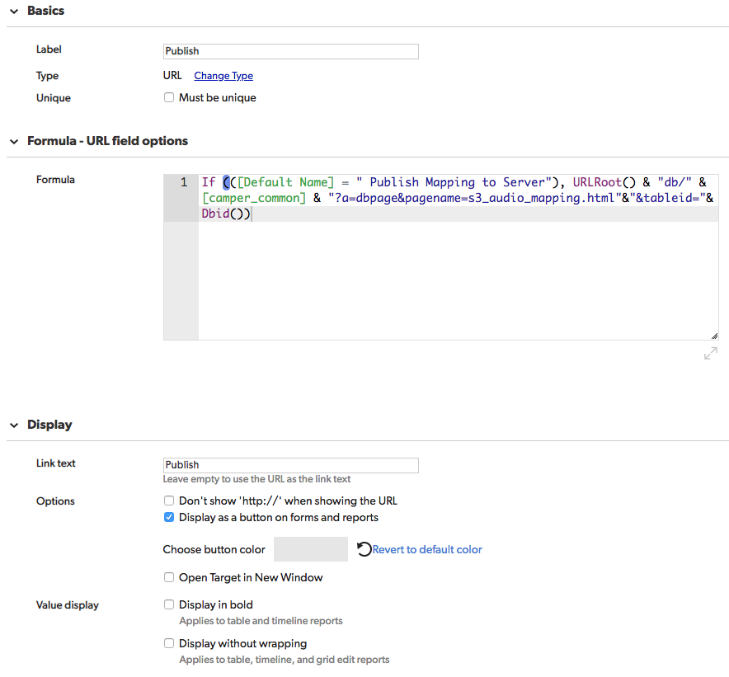

If (([Default Name] = " Publish Mapping to Server"), URLRoot() & "db/" & [camper_common] & "?a=dbpage&pagename=s3_audio_mapping.html"&"&tableid="& Dbid())

